Wind

Colton Dudley

Abstract—

1. Introduction
2. What we are doing:
   1. Surface roughness
   2. Eddy size
   3. Von karman constant
   4. Molecular diffusivity vs turbulent diffusivity
3. Why this is important
   1. Pollutants in atmosphere
   2. Combustion
   3. Containments
4. Theory

Fluid can be thought of as either smoot or turbulent. In the atmosphere the wind is smooth above the planetary boundary layer (~500m) but below that there is turbulence. The turbulence can be thought of as a deviation from the average wind speed, $\overline{u}(z)$, at a height z:

$$\begin{aligned}u^{'}\left(z,t\right)=u\left(z,t\right)-\overline{u}\left(z\right)\#\left(1\right)\end{aligned}$$

Where $u\left(z,t\right)$ is the instantaneous wind speed at time t. deviance in the vertical windspeed can be described in the same manner to get a vertical component, $w\left(z,t\right)$. From this many other properties of the fluid can be derived, such as the shearing stress, $η$:

$$\begin{aligned}η=pv\frac{du}{dz}=ρK_{m}\left(z\right)\frac{du}{dz}\#\left(1\right)\end{aligned}$$

Where $ρ$ is the mass density of the fluid. Km is the turbulent diffusivity of momentum or the kinematic eddy viscosity, which describes how much energy is transferred from the eddys, or how much energy is transferred between vertical layers of flow. Another important property is the eddy velocity of friction, or friction velocity, denoted by u*. This is found by the equation:

$$u*=\sqrt{\frac{η}{ρ}}$$

By assuming that $u' = w' = u*$, then u* can be found by:

$$\begin{aligned}u*={\left(u^{'}w^{'}\right)}^{\frac{1}{2}}\#\left(1\right)\end{aligned}$$

Using these equations, a wind profile equation can be written to give the average wind speed as a function of height:

$$\begin{aligned}\overline{u\left(z\right)}=\frac{u*}{k}ln\left(\frac{z}{z_{0}}\right)\#\left(1\right)\end{aligned}$$

Where k is the Von Karmen constant, which is universally taken to be 0.4 and $z_{0}$ is the roughness length of the surface that the wind is blowing over. $z_{0}$ can also be thought of as the height that the wind speed theoretically drops off to 0m/s.

A last useful number to find is the gradient Richardson number (*Ri*), which relates the buoyancy to vertical wind shears. This is a measure of the stability of the fluid with a small magnitude *Ri* showing that the fluid is neutrally stable. The gradient Richardson number is given by:

$$\begin{aligned}Ri=\frac{g}{T}\frac{\frac{dT}{dz}}{{\left(\frac{du}{dz}\right)}^{2}}\#\left(1\right)\end{aligned}$$

Where T is the temperature and g is the acceleration due to gravity.

1. Experimental Method

Wind is commonly measured by mechanical anemometers which have blades or cups that spin in the wind. However, for this application thermal anemometers were used. These work by heating an element to a constant temperature (a ‘hot wire’) and measuring cooling of the wire as the wind flows across it [CITE]. Thermal anemometers have an advantage over mechanical ones as they can detect small changes in wind speed much more rapidly which is important for taking a time series of data. A disadvantage however is their inability to measure wind direction. All measurements in this experiment were made using testo405i thermal anemometers, with data being collected over Bluetooth on the testo Smart Probe app on a 9th generation Ipad. These probes were stated to have an accuracy of $0.1m/s±5\%$ [CITE].

1. Calibration

The sensors were calibrated by holding them all in a line and walking across the lab room (about 5 meters) at a uniform pace for 30 seconds. The detectors were held over our head in order to minimize interference from our bodies as we walked. A coefficient was then obtained for each detector so that it’s average would equate to the average windspeed of all the detectors.

The experimental setup varied from day to day to day. The basic setup used 6 sensors arranged from a height of 0.45m off the ground to 2.25m. Data was collected in several locations; an open field, a snowy field, a pavement, the 8th floor balcony and an ice-covered lake. Surface roughness is affected by surfaces $Z_{max}×40$ downwind where $Z_{max}$ is the max height of the detector setup. [CITE] An effort was made to place the detectors at least 80m downwind from any obstructions (trees, shrubs, or walls) in order to avoid this effect. The location and approximate distance from obstructions downwind for all detectors can be seen in appendix A.

1. Results

First the gradient Richardson number was calculated in order to determine that stability conditions hold. Ideally a Richardson number of *Ri*<|0.1| would be expected however a Ri from 0.1 to 10 may still hint that MORE HERE [CITE]

1. Surface Roughness

The surface roughness can simply be calculated by plotting average wind speed against height on a log scale. An example of this for snow can be seen in FIGX

1. Turbulence

The outer scale of the turbulence can be found by looking at the autocorrelation of windspeed. The autocorrelation should first reach 0 at a lag time that is the outer scale of the turbulence. This can be seen in FIGX

However due to noise there is a large fluctuation from the expected autocorrelation. This can be accounted for by taking an integral of the plot. This finds a lag time of roughly DATA HERE. Another method of determining eddy size is by taking a Fourier transform of the wind speed as a function of time. [CITE] The result of this can be seen in FIGX

1. Verifying the Von Karmen constant

The Von Karmen constant can be verified by by comparing the characteristic friction/eddy velocity to the wind profile. Using the assumptions made in [EQUATION] u* was calculated to be 0.09 – 0.12. The gradient of the wind profile was then used to determine Von Karmen constant, giving a result of 0.1-0.37. This is within experimental error of the accepted value of 0.41[CITE]

1. Comparing Molecular to Turbulent diffusivity.
2. Discussion
3. Conclusions

References

[1] “eFunda: Theory of Hot-Wire Anemometers,” Efunda.com, 2019. https://www.efunda.com/ designstandards/sensors/hot_wires/hot_wires_theory.cfm

[2] J. Liljencrants, “Thermal Anemometers,” www.fonema.se, Jan. 28, 2006. http://www.fonema.se/ anemom/anemom.html (accessed Jan. 04, 2023).

[3] Testo, “Thermal anemometer operated with smartphone,” 19811724, Sept. 2020.

[3] M. L. Salby, Fundamentals of Atmospheric Physics. Elsevier, 1996.

[4 ]M. McCann, “Wind Turbulence F2,” Imperial College London, 2022.

APPENDIX

* 1. The location along with approximate distances from obstructions downwind:

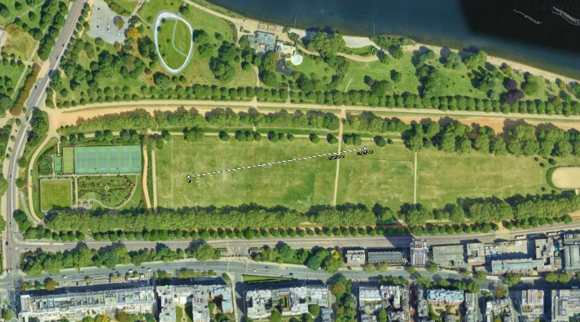

Grass

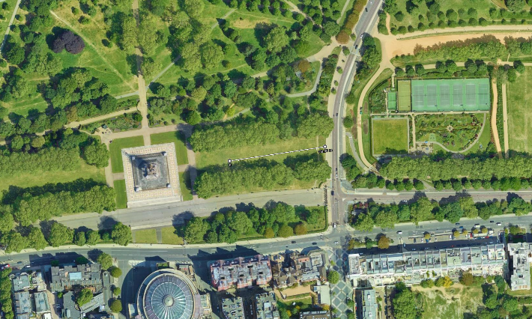

Grass

Ice

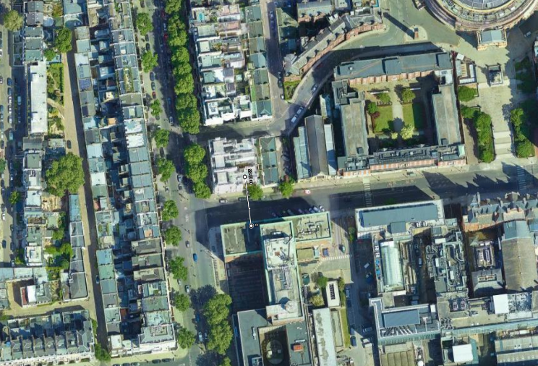

Roof

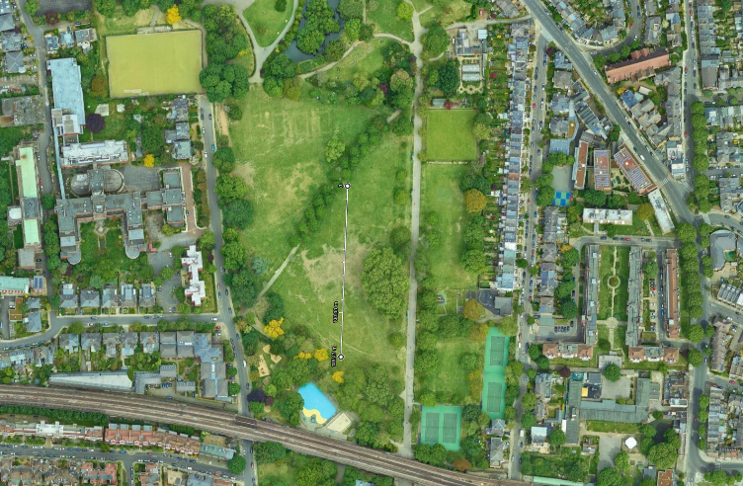

Snow

Cycle 1 Feedback: Good motivation re magnetometers. Main result slide was very well presented. Nice use of literature finding quantum linear MR paper and using it. Also good effort to think about errors. excellent answers to questions. Got a bit bogged down in technical details. It was fine but not very interesting and not the best use of time. Your T^-1 units for mobility are very unusual but dimensionaly correct. However your audience will understand you better it you use the standard terms they are used to. Table in conclusion unreadable - you weren't using most of it - you could have cut it down and expanded the relevant bit. A lot of the slides were a bit busy with too much technical detail.

Cycle 2 Feedback : The main comment is the language is not up to standard for a scientific paper, never use "you" or familiar tone. You need to work on your abstract, I was struggling to understand what you meant. There are some formatting issues (missing page number, commas in front of equations, references after full stop, axis labels a bit too small, units capitalisation and not spaced from their number). The experiment was correctly executed, at least for the core Compton scattering measurement. Nice to include an annotated picture of your setup, you're the only one who's done that. I appreciated to see the calibration curve, not many people have done that.